**Philadelphia University**



**Faculty of Information Technology Department of Software Engineering**

**Marking Schema**

**Lecturer :** Dr. M. Maouche

**Coordinator :** Dr M. Maouche

**Internal Examiner :** Dr. A. Moayad

**Course Name**: Software Modeling (721222) **Sections: 2**

**Final Exam**

**First Semester Academic Year:** 2014/15 **Date**: February, 4th , 2015 **Time:** 120 minutes

*.*

**Question1: (14 marks)**

* + - 1. Signal, Change and Time events. (1x3).
      2. Both specify operations but actions have no duration (2) while activities have duration (2).
      3. Structure, behavior, interaction modeling views (1x3).

4. State diagrams are used to describe object behaviors (life cycle) (2)

5. Diagram based style (1), narrative based style (1).

**Question2: (16 marks)**

**A- Use Case Modeling**: (11 marks)

Customer, Member, Shop Staff (2)

(2 marks)

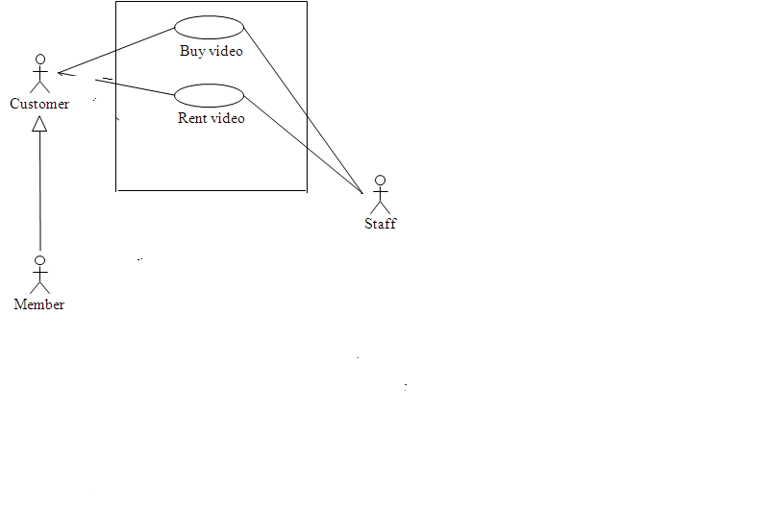

Rent Video Use case may be refined into:

- **First level refinement**: return rented video; lend a video (1)

**- Second level refinement**: Select Video, Look up customer/member information, Produce notices for customers with overdue videos (1)

4.**Rent Video Use case** **includes**  ‘Lend a video’ and ‘Return rented video’ (1);

These two **last include** ‘Select Video’, ‘Look up customer/member information’

(0.5) and ‘Produce notices for customers with overdue videos’ **extends** Return

video use (0.5)

5.Return rented videoslow leveluse case:

trigger event: Customer/Member comes and wants to return a video (0.5)

pre-condition (s): staff is logged on, Customer loaned a video (1)

post-condition: system records that a loaned video is returned. (0.5)

Exceptions: video damaged (0.5), overdue video (0.5)

**B- Class Diagram:**  (3 + 2)

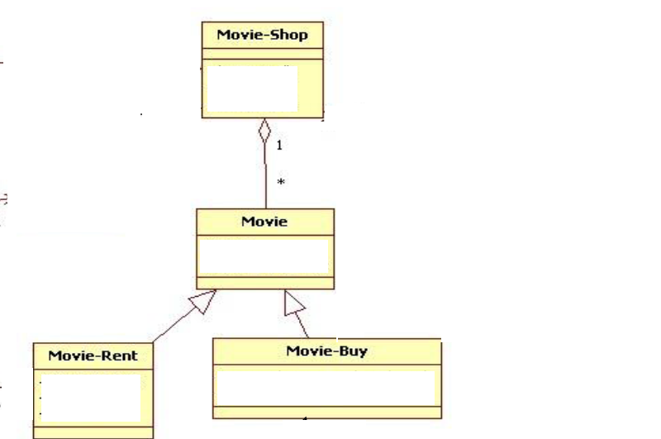

**Question3: (10 marks)**

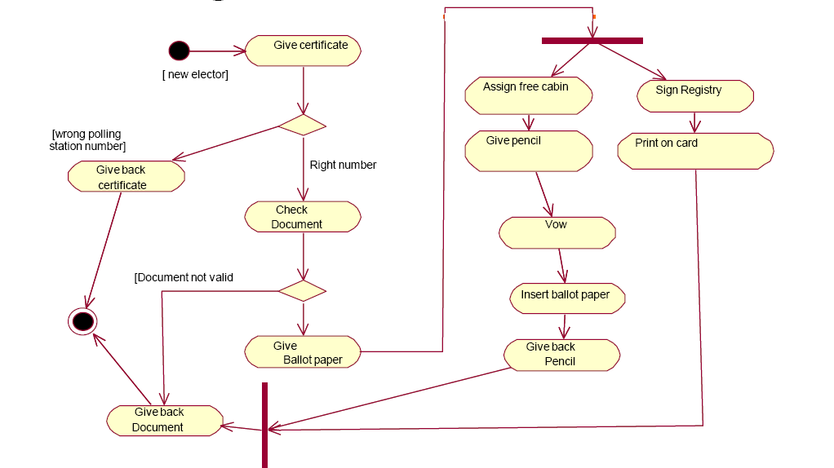

**Question4: (6 marks)**

